# **Product Requirements Document (PRD): Zomato Delivery Experience**

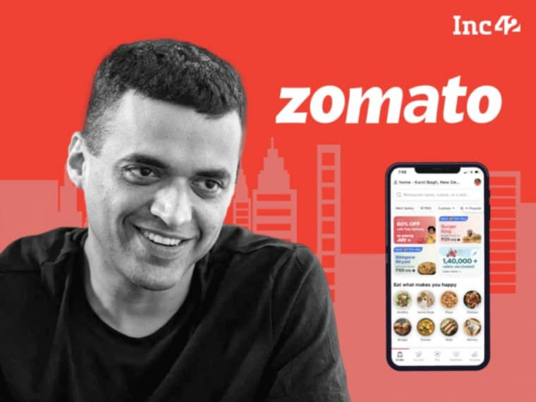

## **1. Introduction to Zomato**

### **1.1 Overview of Zomato**

Zomato is one of the leading food delivery and restaurant discovery platforms, operating across multiple countries with a robust and ever-expanding presence in the food-tech industry. Founded in 2008 by Deepinder Goyal and Pankaj Chaddah, the platform initially started as a simple restaurant review and discovery service, catering to users looking for the best dining options in their locality. Over time, it underwent a significant transformation, leveraging technology, data analytics, and AI-driven insights to become a comprehensive food services ecosystem.

With its deep integration into the food industry, Zomato has evolved into a full-fledged food delivery platform, offering users an unparalleled experience that goes beyond just ordering food. The platform facilitates seamless online ordering, extensive restaurant discovery, table reservations, and exclusive premium dining experiences through its Zomato Gold and Pro memberships. These premium services grant users access to enticing benefits such as discounts, complimentary dishes, and priority bookings at top-tier restaurants, further enhancing customer engagement and loyalty.

Zomato partners with thousands of restaurants, ranging from well-established food chains and fine-dining establishments to small local eateries and cloud kitchens. This extensive network ensures that users can explore and access a vast variety of cuisines and food options right at their fingertips. The platform integrates cutting-edge AI-driven recommendations that analyze user preferences, past orders, and real-time trends to personalize their experience. Customer reviews and ratings also play a crucial role in helping users make informed decisions about their dining choices. Additionally, real-time tracking mechanisms allow users to monitor the progress of their food orders from preparation to doorstep delivery, ensuring a seamless and transparent experience.

Through strategic investments in technology, sustainability initiatives, and innovative customer engagement strategies, Zomato continues to refine and enhance its services, setting new benchmarks in the food delivery and restaurant discovery industry.

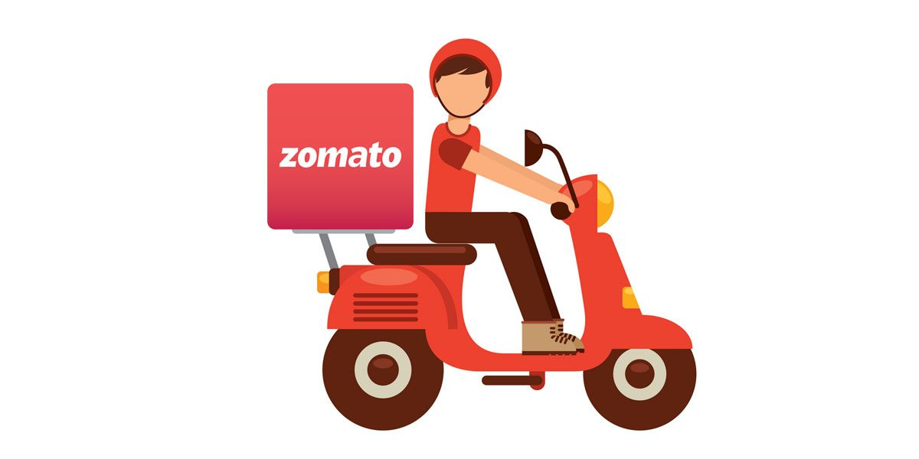

### **1.2 Zomato’s Value Proposition**

### **Vast Restaurant Network**

* + Zomato provides access to a broad range of eateries, from small street vendors offering local delicacies to high-end restaurants known for their gourmet cuisine. This extensive variety ensures that users can choose from a wide spectrum of dining options based on their preferences, budget, and location. Whether it is a user seeking an affordable meal from a food cart, a family looking for a casual dining experience, or a connoisseur craving fine dining at a Michelin-starred restaurant, Zomato caters to all.
  + Beyond conventional restaurants, Zomato also collaborates with cloud kitchens and home chefs, enabling them to reach a broader audience without the need for physical storefronts. This not only diversifies the choices available to users but also promotes small and independent food businesses. Additionally, Zomato actively onboards new restaurants and regional specialty outlets to ensure that its catalog remains dynamic and representative of evolving culinary trends.
  + By leveraging its vast network, Zomato is able to offer hyperlocal recommendations, ensuring that users can explore popular food joints in their immediate vicinity or discover hidden gems in distant neighborhoods. Furthermore, the platform's AI-powered search filters allow users to refine their choices based on cuisine type, pricing, dietary preferences, and user ratings, making food discovery a personalized and seamless experience.
  + Through its continuously expanding restaurant network, Zomato strengthens its position as a comprehensive food services provider, ensuring that every user, regardless of their taste or dining preference, finds a meal that perfectly matches their needs.

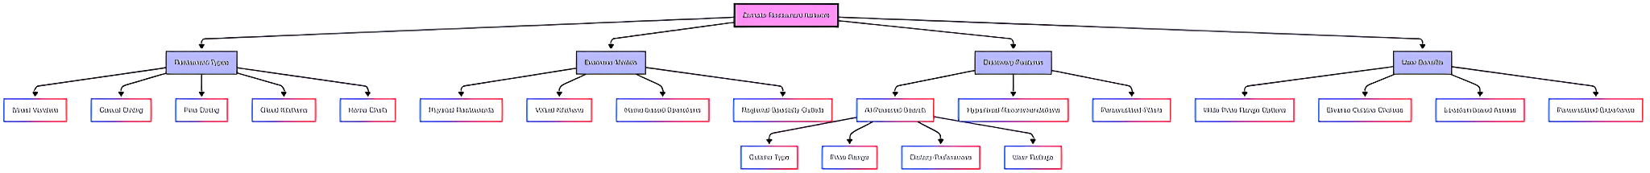

* **AI-Driven Recommendations**:
  + Zomato’s AI-driven recommendation engine plays a pivotal role in enhancing the user experience by providing highly personalized restaurant and food suggestions. This intelligent system leverages multiple data points, including past order history, user browsing patterns, customer reviews, ratings, geographical location, time of day, and trending cuisines to curate tailored recommendations. By continuously learning from user behavior, the AI adapts dynamically, ensuring that the suggestions remain relevant and refined over time.
  + Zomato employs sophisticated machine learning algorithms that analyze massive datasets to identify user preferences and predict their future dining choices. The recommendation engine is designed to cater to a wide range of needs, whether a user is looking for a quick snack, a fine-dining experience, or a specific type of cuisine. Additionally, Zomato’s AI takes into account contextual factors such as weather conditions, popular events in the city, and current demand trends to suggest appropriate meal options. For instance, during monsoon seasons, the system may prioritize comfort foods such as soups and hot beverages, while during festive periods, it may highlight popular festival-special meals.
  + Another key feature of Zomato’s AI-driven recommendations is its ability to generate real-time suggestions based on social proof. If a particular restaurant or dish is trending among users in a specific location, the AI identifies this trend and surfaces it to more users, enhancing discovery and engagement. Additionally, the AI enables users to receive suggestions based on their dietary restrictions, such as vegetarian, vegan, gluten-free, or keto-friendly meals, making it highly inclusive and adaptable to individual needs.
  + To further refine its recommendation system, Zomato integrates user feedback loops. Users can rate the accuracy of the AI’s suggestions, allowing the platform to continually optimize its recommendations and improve user satisfaction. Moreover, Zomato leverages Natural Language Processing (NLP) to analyze user reviews and sentiments, ensuring that highly-rated restaurants with positive customer experiences are given prominence in recommendations.
  + By utilizing AI-driven recommendations, Zomato not only enhances user engagement but also fosters restaurant visibility, helping eateries reach the right audience. This intelligent ecosystem creates a seamless, personalized, and enjoyable dining experience for every Zomato user, making food discovery more intuitive and efficient.  
    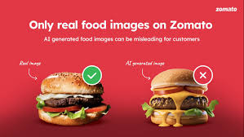
* **Real-Time Tracking**: Users can track their food orders from preparation to delivery.

Zomato’s real-time tracking feature provides users with full visibility into their food order journey, ensuring transparency and reducing uncertainty about delivery timelines. From the moment an order is placed, users receive updates about its progress in real time, allowing them to track their food from preparation to doorstep delivery.

The tracking process is divided into multiple stages, each offering users detailed insights into their order status. These stages include:

* **Order Confirmation:** Once a user places an order, they receive a confirmation notification with an estimated delivery time.
* **Restaurant Acceptance and Preparation:** Users can see when the restaurant accepts the order and starts preparing their meal. The system provides live updates on estimated cooking time based on past restaurant performance and current kitchen workload.
* **Rider Assignment:** The platform assigns a delivery partner to the order, and users receive real-time updates on the rider’s location, name, and contact information.
* **Pickup Stage:** Users get a notification when the food is ready and collected by the delivery partner, ensuring them that their order is on its way.
* **Live Route Tracking:** The app provides GPS-based live tracking of the delivery rider, enabling users to monitor their food’s journey in real-time with estimated time of arrival (ETA) updates.
* **Delivery Completion:** Once the rider reaches the user’s location, they receive a notification prompting them to collect their order, with an option to rate the delivery experience.

Zomato’s real-time tracking system is powered by advanced geolocation technology, integrating GPS navigation to ensure precise tracking. This feature enhances user trust by reducing anxiety about delayed deliveries, providing an accurate ETA, and allowing users to communicate with the rider for any specific instructions.

Additionally, in high-traffic or adverse weather conditions, the system dynamically adjusts ETAs based on real-time factors, ensuring realistic expectations for delivery time. Users can also receive automated notifications if unexpected delays occur, keeping them informed at every stage.

By implementing a robust real-time tracking system, Zomato elevates the food delivery experience, offering customers a seamless, informed, and reliable service.

* **Subscription Model**:

Zomato offers a premium subscription service known as Zomato Gold (previously Pro), designed to provide users with exclusive benefits that enhance their dining and food delivery experience. The subscription model unlocks a variety of perks, including significant discounts on food orders, free deliveries, priority customer support, and early access to top-rated restaurants and special events.

* **Exclusive Discounts:** Zomato Gold/Pro members enjoy discounts on both dine-in and delivery orders. Partner restaurants offer special deals, such as buy-one-get-one-free offers or percentage-based discounts, making dining more affordable for subscribers.
* **Free Deliveries:** Subscribers benefit from zero delivery charges on select orders, reducing overall costs and encouraging frequent usage.
* **Priority Access to Premium Restaurants:** The subscription model provides early access to high-demand restaurants and curated dining experiences, allowing members to secure reservations at exclusive venues.
* **Faster Customer Support:** Zomato Gold/Pro members receive priority assistance through a dedicated customer service channel, ensuring quicker resolution of issues related to orders, payments, or restaurant queries.
* **Exclusive Early-Bird Offers & Events:** Members gain access to special dining festivals, culinary events, and limited-time promotional offers before they are available to the general public.

The subscription model is designed to cater to frequent diners and food enthusiasts who seek additional value from their Zomato experience. By offering a range of incentives, Zomato strengthens user retention, encourages loyalty, and enhances engagement with the platform. The model also benefits restaurant partners by driving more traffic to premium dining establishments, creating a mutually beneficial ecosystem for all stakeholders.

* **Customer Support**:

Zomato offers round-the-clock customer support to ensure seamless assistance for delivery-related concerns. Users can access 24/7 help through multiple channels, including live chat, phone support, and email assistance.

* **Live Chat Support:** Zomato provides an in-app chat feature that connects users with support agents in real-time. This feature is ideal for resolving queries related to order tracking, refunds, and complaints.
* **Phone Support:** For more urgent issues, such as missing items or incorrect orders, users can directly call Zomato’s customer service, ensuring a quick resolution.
* **AI-Powered Self-Help:** The platform integrates AI-driven automated responses for frequently asked questions, allowing users to resolve minor concerns without human intervention.

Zomato’s comprehensive support system enhances customer confidence and satisfaction by addressing concerns efficiently and ensuring a smooth food delivery experience.

* **Sustainability Initiatives**:
  + Zomato has been actively working towards integrating sustainability into its operations by adopting eco-friendly measures aimed at reducing its environmental impact. The platform has introduced sustainable packaging solutions to minimize plastic waste and promote the use of biodegradable, recyclable, and compostable materials for food delivery. Additionally, Zomato collaborates with restaurant partners to encourage the adoption of sustainable practices, including the reduction of single-use plastics and implementation of eco-conscious packaging alternatives.
  + To further its commitment to sustainability, Zomato has launched carbon footprint reduction programs that focus on optimizing delivery routes, promoting the use of electric vehicles (EVs) for food delivery, and investing in carbon offset initiatives. The company is also exploring ways to integrate reusable packaging options to reduce waste generation significantly.
  + Moreover, Zomato’s sustainability initiatives extend to food waste reduction through partnerships with food banks and NGOs to redistribute surplus food to the underprivileged. By implementing these environmentally responsible initiatives, Zomato is not only enhancing its corporate social responsibility efforts but also actively contributing to a more sustainable future for the food delivery industry.

## **2. Competitive Landscape**

Zomato operates in a highly competitive food delivery space, facing strong competition from both local and international players. The food delivery industry is dominated by a few key players, each offering unique value propositions to gain a larger market share.

### **2.1 Major Competitors of Zomato**

#### **2.1.1 Swiggy**

**Overview:** Swiggy is one of Zomato’s strongest competitors in India. Launched in 2014, Swiggy has established itself as a major food delivery giant, with a robust delivery network and an intuitive user experience.

**Key Features:**

* Extensive restaurant partnerships
* Swiggy Genie (parcel delivery services)
* Swiggy Instamart (quick grocery deliveries)
* AI-driven food recommendations
* Swiggy One (subscription model for free deliveries)

#### **2.1.2 Uber Eats (International Markets)**

**Overview:** Uber Eats is a global food delivery service integrated with the Uber ride-hailing ecosystem.

**Key Features:**

* Global presence in multiple countries
* Integration with Uber’s ride service
* AI-powered recommendations
* Personalized deals and discounts
* Seamless in-app tipping and review system

#### **2.1.3 DoorDash**

**Overview:** DoorDash dominates the U.S. market and has expanded into international markets.

**Key Features:**

* DashPass subscription for free deliveries
* Contactless delivery options
* High-speed logistics network
* AI-driven restaurant discovery
* Grocery and convenience store deliveries

#### **2.1.4 Deliveroo**

**Overview:** A major food delivery player in Europe and the UK, Deliveroo has gained prominence through partnerships with high-end restaurants.

**Key Features:**

* Premium dining delivery
* Multi-order capabilities (order from multiple restaurants in one go)
* Subscription-based free delivery
* Corporate meal plans

#### **2.1.5 Foodpanda**

**Overview:** Operating in various Asian markets, Foodpanda offers a mix of restaurant and home-cooked meal deliveries.

**Key Features:**

* Flexible meal subscriptions
* Real-time order tracking
* AI-driven recommendations
* Contactless delivery

## **2. User Pain Points in Food Delivery**

Despite its success, Zomato’s delivery experience is not without challenges. Below are the major pain points users face when ordering food online:

### **2.1 Long Delivery Times**

**Issue:** Users often experience longer-than-expected delivery times, especially during peak hours, bad weather conditions, or due to traffic congestion. This can be particularly frustrating when users are relying on timely deliveries for their meals.

**Impact:** Delays in food delivery lead to frustration among customers, resulting in a poor user experience, increased order cancellations, and negative reviews that can harm the platform’s reputation. Users may also migrate to competitors offering faster service.

**Potential Solution:**

* **AI-powered demand forecasting:** Advanced algorithms can predict demand surges based on historical data, weather patterns, and real-time order volumes, allowing Zomato to allocate delivery personnel more efficiently.
* **Optimized delivery routes:** Leveraging machine learning and GPS data to identify the fastest delivery routes, reducing the time taken for orders to reach customers.
* **Dynamic pricing incentives:** Encouraging more delivery partners to be available during peak hours through surge pricing, ensuring adequate rider availability and preventing delays.
* **Order batching and smart assignment:** Assigning multiple nearby orders to a single rider to improve efficiency while ensuring food quality is maintained.
* **Predictive ETAs and real-time adjustments:** Providing users with more accurate estimated delivery times and adjusting them dynamically based on live traffic and restaurant preparation times.

### **2.2 Poor Food Packaging**

**Issue:** Leaking, soggy, or damaged packaging negatively affects the user experience, leading to food spillage and reduced quality upon arrival.

**Impact:** Poor packaging results in customer dissatisfaction, increased complaints, and potential health risks due to compromised food safety. Users may hesitate to reorder from restaurants with a history of packaging issues, leading to lost revenue for both Zomato and restaurant partners.

**Potential Solution:**

* **Standardized packaging guidelines:** Partnering with restaurants to implement tamper-proof, spill-resistant, and eco-friendly packaging to enhance food safety and maintain quality.
* **Real-time customer feedback mechanisms:** Enabling users to rate packaging quality and report issues, allowing Zomato to track trends and address recurring problems with specific restaurants.
* **Incentives for quality packaging:** Encouraging restaurants to use superior packaging materials by offering visibility boosts, promotions, or other incentives for compliance with packaging standards.

### **2.3 Incorrect Orders or Missing Items**

**Issue:** Users frequently receive incorrect items or missing components in their orders.

**Impact:** Receiving the wrong order or missing food items leads to disappointment, frustration, and an increased reliance on customer support for resolutions. This negatively affects user trust, leading to lower retention rates and reduced brand loyalty.

**Potential Solution:**

* **AI-driven order verification before dispatch:** Utilizing AI-powered image recognition and barcode scanning to ensure order accuracy.
* **Restaurant accountability through rating systems and penalties:** Implementing stricter quality control measures, penalizing repeat offenders, and rewarding restaurants with a strong accuracy record.

### **2.4 High Delivery Charges**

**Issue:** Users often complain about fluctuating delivery charges, particularly in remote or high-demand areas. Many customers feel that the high delivery fees significantly impact the overall affordability of ordering food online, making them reconsider their decision or opt for alternative platforms offering lower charges.

**Impact:** High delivery costs contribute to cart abandonment, reducing overall order frequency. Customers seeking budget-friendly options may be discouraged from placing an order, leading to a drop in customer retention. Additionally, competitors offering lower or fixed delivery charges may attract Zomato’s user base, further intensifying market competition.

**Potential Solution:**

* **Subscription models offering free delivery:** Expanding Zomato Gold/Pro to include unlimited free deliveries for subscribers, encouraging user retention and engagement.
* **Dynamic pricing based on demand analysis:** Implementing AI-driven pricing strategies that adjust delivery charges based on order volume, distance, and rider availability, ensuring fair and transparent costs.
* **Strategic partnerships with logistics providers:** Optimizing delivery efficiency through partnerships with third-party logistics companies to reduce operational costs and pass savings onto customers.
* **Loyalty rewards and cashback programs:** Introducing incentives for frequent users, such as cashback on delivery charges, to create a more cost-effective and rewarding experience.

### **2.5 Customer Support Delays**

**Issue:** Slow responses to complaints regarding refunds, missing orders, or delivery delays can frustrate users who expect prompt assistance.

**Impact:** Delayed responses from customer support can reduce overall customer satisfaction and lead to decreased loyalty. Users may turn to competitors with better customer service, impacting Zomato’s retention rates and brand trust.

**Potential Solution:**

* **AI-powered chatbots for instant resolutions:** Implementing automated chatbots to handle common complaints and provide quick solutions.
* **Priority-based escalation for critical complaints:** Ensuring urgent issues receive immediate attention and are escalated to human agents when necessary.
* **24/7 multilingual support:** Expanding support services to cater to diverse user demographics, improving accessibility and response efficiency.

### **2.6 Limited Customization Options**

**Issue:** Some users require extensive food customization options due to dietary restrictions, allergies, or personal preferences. The lack of detailed customization features may prevent users from ordering their preferred meals, leading to dissatisfaction.

**Impact:** Users with specific dietary needs may feel alienated, leading to reduced engagement with the platform. This can also result in a loss of potential revenue from customers who prefer more control over their meal choices.

**Potential Solution:**

* **Implementing detailed customization features:** Allowing users to specify ingredients, spice levels, portion sizes, and other modifications to better cater to their preferences.
* **Partnering with restaurants to accommodate special requests:** Encouraging eateries to offer flexible customization options, ensuring a more personalized ordering experience.
* **AI-driven menu personalization:** Leveraging AI to suggest suitable meal modifications based on a user’s dietary history and preferences.

## **4. Enhancing Zomato’s Delivery Experience**

### **4.1 AI-Powered Logistics Optimization**

Zomato employs AI-driven logistics to enhance the efficiency of food deliveries. These systems help optimize delivery routes, allocate riders strategically, and predict demand to ensure faster service.

#### **Features of AI-Powered Logistics:**

* **Demand Prediction Models:** AI forecasts peak demand hours, allowing for pre-emptive rider allocation and reduced waiting times.
* **Real-Time Traffic Data Integration:** The system analyzes live traffic conditions to suggest the fastest routes, minimizing delays.
* **Dynamic Rider Allocation:** Zomato dynamically assigns riders based on location proximity, ensuring optimal delivery efficiency.
* **Weather-Based Adaptation:** AI considers weather conditions to suggest optimal delivery strategies and prepare for potential slowdowns.

### **4.2 Premium Packaging Standards**

Packaging plays a critical role in ensuring food quality and customer satisfaction. Zomato is committed to enhancing packaging standards to improve the overall delivery experience.

#### **Key Features of Premium Packaging:**

* **Eco-Friendly Packaging:** Partnering with restaurants to promote biodegradable, recyclable, and compostable packaging materials.
* **Tamper-Proof Seals:** Implementing secure packaging to prevent contamination and unauthorized access to food orders.
* **Spill-Resistant Design:** Encouraging the use of sturdy containers and leak-proof packaging for liquid-based dishes.
* **Heat-Retaining Insulation:** Introducing thermal packaging solutions to maintain food temperature during transit.
* **Packaging Quality Rating System:** Allowing users to rate packaging quality, encouraging restaurants to adopt best practices.
* **User Feedback Integration:** Leveraging AI to analyze customer feedback and recommend packaging improvements to partner restaurants.

By elevating packaging standards, Zomato enhances food presentation, prevents spillage, and ensures that meals arrive in optimal condition, leading to improved customer satisfaction and reduced complaints.

### **4.3 Advanced Order Verification System**

* AI-powered order scanning before dispatch.
* Implementing real-time quality control via image recognition.

### **4.4 Subscription-Based Free Delivery Model**

* Expanding Zomato Gold/Pro benefits to include unlimited free deliveries.
* Introducing tier-based pricing to attract different customer segments.

**4.5 Enhanced Customer Support with AI**

Zomato aims to streamline customer support processes and improve complaint resolution efficiency through AI-driven automation.

#### **AI-Powered Support Features:**

* **Instant Chatbot Assistance:** AI chatbots provide quick responses to common queries, reducing wait times.
* **Automated Refund Processing:** AI-driven verification systems expedite refund approvals for valid claims.
* **Priority-Based Complaint Escalation:** AI categorizes complaints based on urgency and assigns them to the appropriate support team for faster resolution.
* **Predictive Issue Resolution:** AI anticipates potential order-related issues (e.g., delays, missing items) and proactively alerts users with compensation options.
* **Multilingual Support Integration:** AI-powered translation services enable seamless communication across diverse user demographics.

By leveraging AI, Zomato can improve response times, enhance customer satisfaction, and reduce the overall burden on human support agents.

### **4.6 Enhanced Customization Features**

* Allowing users to specify allergy/dietary preferences at the account level.
* Partnering with restaurants to offer ingredient swap options.

**4.7** **Gamification and Loyalty Rewards**

To drive user engagement and long-term loyalty, Zomato can introduce gamification elements and reward programs.

#### **Key Gamification Features:**

* **Streak-Based Discounts:** Users earn rewards for ordering consistently over consecutive days.
* **Leaderboard Challenges:** Encouraging users to compete for exclusive discounts by engaging with the platform.
* **Personalized Achievement Badges:** Recognizing loyal customers with exclusive perks and discounts.
* **Referral Incentives:** Users earn discounts or free deliveries by referring friends to the platform.
* **Surprise Cashback Offers:** AI-driven personalized cashback incentives based on ordering behavior.

These initiatives will encourage repeat usage, enhance customer retention, and strengthen Zomato’s position as the go-to food delivery platform.

By implementing these enhancements, Zomato can elevate its delivery experience and strengthen its market position as a leading food-tech innovator.

## **5. Conclusion**

Zomato has established itself as a market leader in the food delivery industry. However, improving delivery speed, packaging quality, order accuracy, and customer support can further elevate the user experience. By leveraging AI-driven optimizations, enhancing customer support, and introducing premium packaging standards, Zomato can maintain its competitive edge and drive user loyalty in an ever-evolving market.